1. UML DIAGRAMS
   1. Structural Diagrams
   2. Deployment Diagram

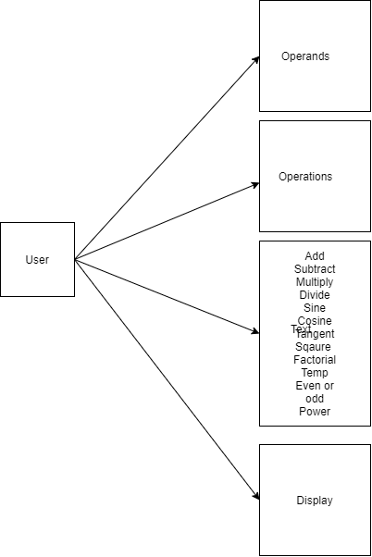

Object Diagram

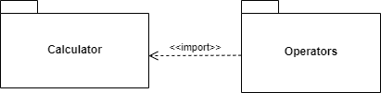

* 1. Behavioral Diagrams

## High Level Use Case Diagram

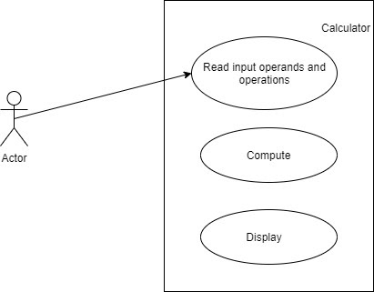

Low Level Use Case Diagram

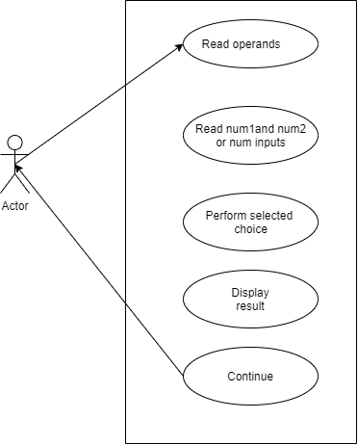

Activity Diagram

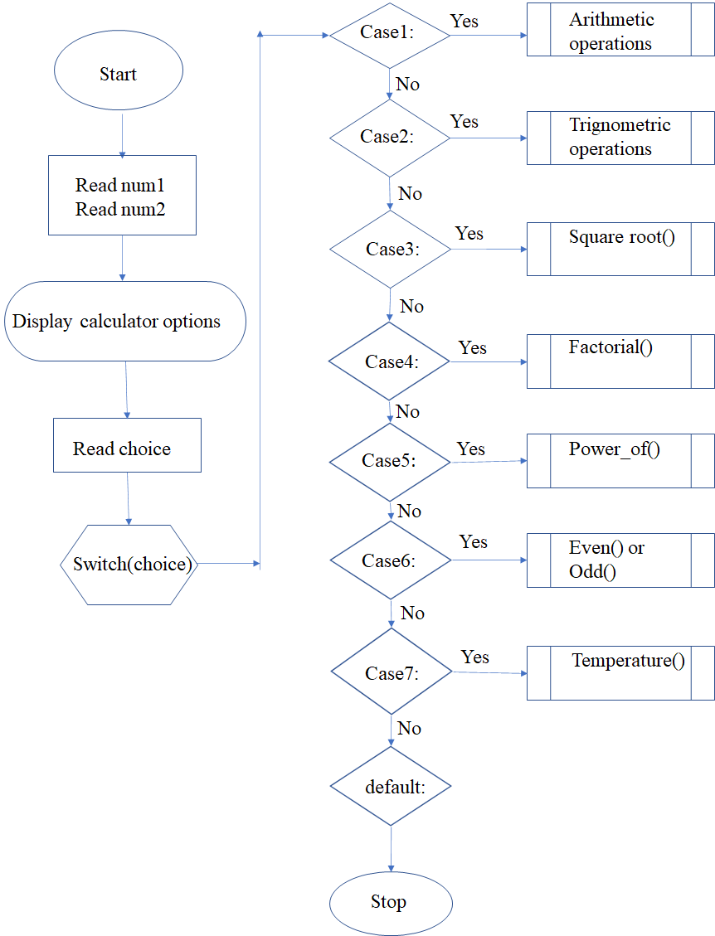

Sequence Diagram

